 Mortgages & Leverage
A huge cause for the wealth gap between working/middle class people and the Top 2% is their perception around debt.
For their entire lives the working middle class is taught that debt is bad. The general rule of thumb is to avoid debt at any cost and try to live below your means. Which was sound advice for many, until the cost of living out paced today’s wages and instead of living below their means, they started filling the gap by using credit, otherwise known as bad debt.
In reality all debt is not bad.
There is good debt and there is bad debt.
Bad debt refers to debt used to purchase liabilities; things that take money out of your pocket every month or offer no return on investment.
Good debt refers to debt used to purchase assets; things that put money in your pocket every month.
The top 2% have learned how to master debt and to have it work for them rather than against them.
In this module we will unlock these secrets of debt and OPM (other people's money) so you will have a true understanding of how to strategically leverage debt to build wealth like the top 2%
Using your mortgages and the fundamentals of leverage can catapult you quickly with your investment portfolio. Understanding the principles of leverage is key to your growth. The following webinars cover various aspects of leverage.

Curriculum
Your Investment Binder
- TEXT & IMAGES
Edit
Your Investment Binder
Open your investment binder and click on the cashflow tab. This will take you to the page where you have entered all of your income and expenses (if you have not completed this already, do this now!) At the bottom of the spreadsheet is your Monthly Residual Income. Please take note of this amount and identify if there is a surplus or a deficit.
If there is a surplus, that is fantastic! Record this amount, but also be prepared to improve it.
If there is a deficit, this needs to be addressed immediately, by making sure all “bad debt” is accounted for. Take note of this number and immediately adjust your personal expenses in the spreadsheet and record that number. If there is still a deficit every month you need to account for that deficit by making more money. Do not hide from this fact or feel embarrassed or ashamed. It is important that you face this fact and own it so you do something about it and change it!
Record this amount in your goal sheet of how much income you need to make to fill this gap and lets start working towards it!


View more
- RESOURCE
InvestmentBinderNetworth.xlsx
Download link visible
- TEXT & IMAGES
Edit
Using the Investment Binder, open the Registered Funds and Credit tab. Record all of your savings (assets) and all of your liabilities (credit card and LOC debt). Make sure to update this on a regular basis. This will be used to track your progress as you begin your investment journey.


Curriculum
Debt Reduction Calculator
- TEXT & IMAGES
Edit
Debt Reduction
Understanding your debt is key to this exercise. Check out this Debt Reduction Calculator to start paying off debt today!

- RESOURCE
Debt-reduction-calculator.xls

Credit Score Notes
- TEXT & IMAGES
Edit
Credit Score
Having and maintaining a healthy credit score is an important part of building wealth! Monitor your credit score every month to make sure it is improving or maintaining a good credit status.

*RECOMMENDED READING - The Richest Man in Babylon

Download - Notes on the Credit Score for some credit repair and maintenance tips!
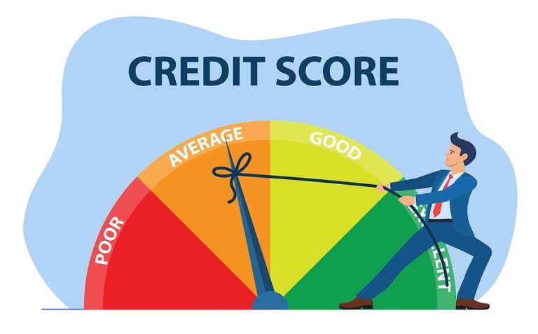
View more
- RESOURCE
RPI Notes on the Credit Score.pdf

Having a Mortgage Plan
- TEXT & IMAGES
- Edit

Importance of Creating a Mortgage Plan
- Before you start looking to purchase homes, you need to know your buying power, so you know what price of homes you are able to qualify for.
- The best person to help you do this is a mortgage specialist who will help you create your mortgage plan.
- A mortgage plan will help you avoid common obstacles experienced by real estate investors
- 
- Watch the webinar below on Mortgage Secrets Exposed -
- Learn to Overcome the Top 5 Mortgage Obstacles

Mortgage Document Checklists
- Download the following mortgage checklist document. The list can seem very daunting to new mortgage seekers, but it doesn’t have to be, if you’re prepared. This mortgage loan documents checklist will help prepare you with the correct mortgage documents to ensure your mortgage application goes smoothly.
- The actual list of documents your lender requests may vary, depending on the lender, the mortgage you want and your financial situation. Ask the lender for a list of paperwork you might need to provide, and start collecting it before you begin the application process.
- Having everything ready from the get-go will help you close on the home with less stress.
- RESOURCE
- Mortgage Docs Required - Canada.pdf
- Download link visible
- RESOURCE
- Mortgage Docs Required - US.pdf
- Download link visible
- RESOURCE
- Mortgage Docs Required - UK.pdf
- Download link visible
- RESOURCE
- Mortgage Docs Required - AU.pdf
- Download link visible
- TEXT & IMAGES
- Edit
- Another reason to have a mortgage plan is so you do not become out leveraged and unable to buy more properties.
- Watch this webinar on Zero Impact Mortgages and learn how to buy an unlimited amount of investment properties

- Conventional lending is not your only option. Another option is to use a Private Lender or a hard money lender.
- Watch this webinar to learn more about Private Lending
- VIDEO

Private Lending Downloads
Private lending can be an excellent option for foreign nationals wanting to invest in the US as well as flipping homes.
Check out these downloads below to learn about different options for flippers
- US Private Lending Requirements for Foreign Nationals
- Flipping Homes in Canada *Sue’s flip program
- Flipping Homes in the US * Flip Co

How to Strategically Leverage
Robert Kiyosaki, author of Rich Dad, Poor Dad, is often credited with the quote “Leverage is the reason why some people are rich, and others aren’t.”
Leverage is the use of various financial instruments or borrowed capital—in other words, debt—to increase the potential return of an investment.
Although leverage is important, strategic leverage is even more important.
Strategic leverage means to create a leverage strategy alongside your wealth professionals to identify available equity in existing assets and mitigate risk.
It’s time to review your wealth binder and identify available capital you can leverage to grow your wealth.
This can be equity in existing assets such as your personal residence or investment properties, lines of credit or even credit cards.
One great strategy for Canadians that can turn your house from a liability into an asset is the Smith Manoeuvre™.
The Smith Manoeuvre™ is a legal tax strategy that effectively makes interest on a residential mortgage tax-deductible in Canada. As a financial planning strategy, the Smith Maneuver involves converting the interest a homeowner pays on their mortgage into tax-deductible investment loan interest.
Learn more about this amazing strategy and how it can give you money to invest, saving you taxes, and helping you pay off your personal residence even faster!
Complete the activities below
Watch this webinar - Smith Manoeuvre™ for Canadians - webinar
Money is not the only thing you can leverage.
If you are a full time Real Estate Investor, looking to create your Real Estate business, you can leverage your knowledge , experience and systems that you have mastered throughout the years, by offering other investors an excellent ROI (return on Investment) as your Joint Venture Partner, saving them time and money!
This terminology, often referred to as OPM - Other People’s Money, is often thrown around carelessly in the Real Estate Investing world, but it is NOT to be taken lightly.
The majority of lawsuits in Real Estate Investing are amongst Joint Venture Partnerships gone wrong!
Rewatch the Joint Venture webinar if you are interested in leveraging your time, knowledge and experience as a Real Estate Investor in exchange for capital and buying power.

Bonus Recommendation
Purchase the
Joint Venture Workshop
in the RPI eStore - Use your Member code to receive 25% off your purchase
This online course will teach you a proven system for acquiring funding partners helping you grow your real estate portfolio and real estate business.


Canadians
For more information on The Smith Manoeuvre™️ and The Smith Manoeuvre™️ educational products,please visit their website at
www.smithman.net
and receive a 15% discount on the best-selling book, Master Your Mortgage for Financial Freedom, The Smithman Calculator, and The Smith Manoeuvre™️ Homeowner Course, by entering Coupon Code
DT9WFHSGJI
.
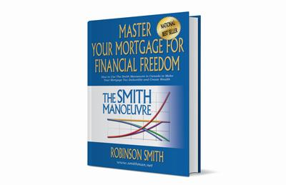
Master Your Mortgage for Financial Freedom book

The Smith Manoeuvre™️ Homeowner Course
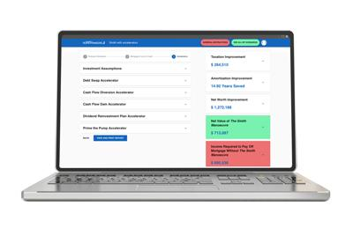
Smithman Calculator Access

